**Learning Objectives**

* To grasp image tag in HTML;
* To grasp video tag in HTML;
* To grasp audio tag in HTML;
* To grasp iframe tag that can be embedded into other web pages in HTML.

**Learning Contents**

* img tag - image
  + Image is the first non-text content appearing in a web page and a sort of a multimedia resource. Image resources generally include .jpg, .png, .gif and .bmp…Almost images in all formats can be embedded into a web page.
  + In HTML, images are indicated with a single tag.tag has a very important src attribute, which defines resource address of the image. The src attribute can be either a relative address or an absolute address.
  + The following is an example of img tag:

<p>

I am an image.

<br>

<img width="500" height="250"

src="https://upload.wikimedia.org/wikipedia/commons/thumb/6/61/HTML5_logo_and_wordmark.svg/240px-HTML5_logo_and_wordmark.svg.png">

</p>



* In the above example, the image is set to be 500px in width and 250px in height. If we do not set width or height of an image, the image will be displayed as it is.
* img tag is an inline element which is not on its own line separately. Instead, it is displayed in a line in the image size set. For example:

<p>

i am a

<img width="100px" src="https://media.istockphoto.com/photos/red-apple-with-leaf-isolated-on-white-background-picture-id185262648?k=6&m=185262648&s=612x612&w=0&h=u9rMspGGTOkgUSzZ6INtT_Ww4NpGz9zHMGRmIJJjBqQ=" alt="">

apple.

</p>

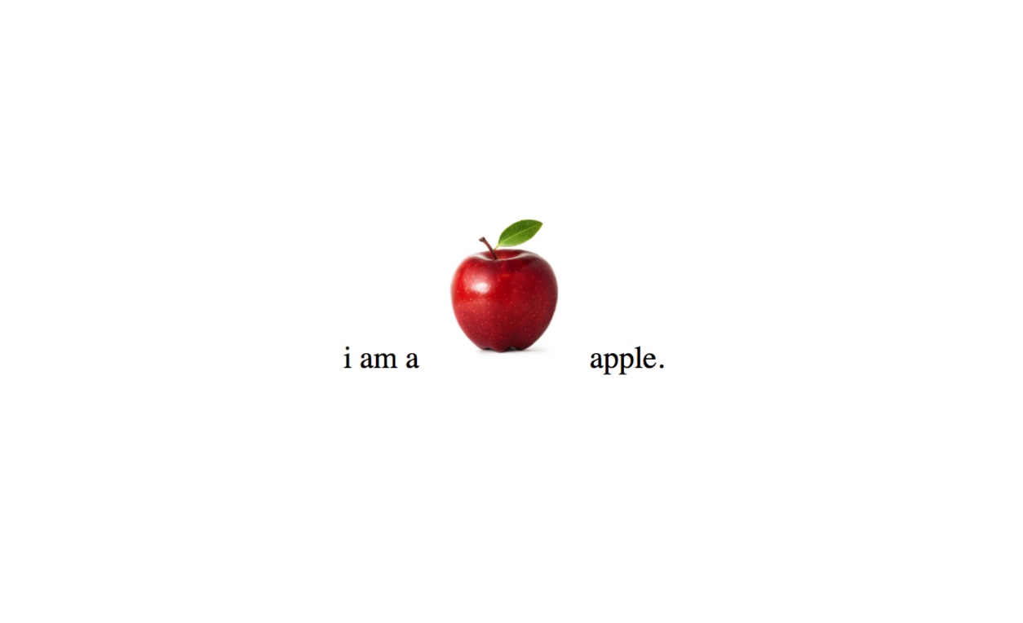

* video tag - video
  + Video tag enables us to simply embed a video. For example:

<video src="rabbit320.webm" controls>

<p>Your browser doesn't support HTML5 video. Here is a <a href="rabbit320.webm">link to the video</a> instead.</p>

</video>

* src attribute relates to video resources to be embedded into a web page. controls attribute enables users to have a control access to videos so that users can control pause, play and other functions of videos.
* In the video tag, there is a paragraph which is called backup paragraph. When the browser does not support video tag, the backup paragraph will appear. In the above example, a link is added for the video file so that users may click on it to access it.
* Video tag has some other attributes. For example:
  + width/height. It controls size of the video. When we adjust size of the video, the video will keep a fixed aspect ratio, and the part not filled by the video content will be displayed in default background color.
  + autoplay. The attribute enables automatic display of video content, even if the remaining part of the web page has not been loaded completely.
  + muted. The attribute enables a mute state by default when the video is played.
  + poster. Like the img tag, it relates to a URL of an image. The image is displayed as a poster of the video before play of the video.
  + preload. The attribute is generally used to cache large video files. It has the following values:
    - none: No buffering.
    - auto: Cache video files after loading the web page.
    - metadata: Buffer metadata of videos only.
* audio tag - audio
  + Usages of audio tag are almost the same as video tag except some subtle differences. For example:

<audio controls>

<source src="viper.mp3" type="audio/mp3">

<source src="viper.ogg" type="audio/ogg">

<p>Your browser doesn't support HTML5 audio. Here is a <a href="viper.mp3">link to the audio</a> instead.</p>

</audio>

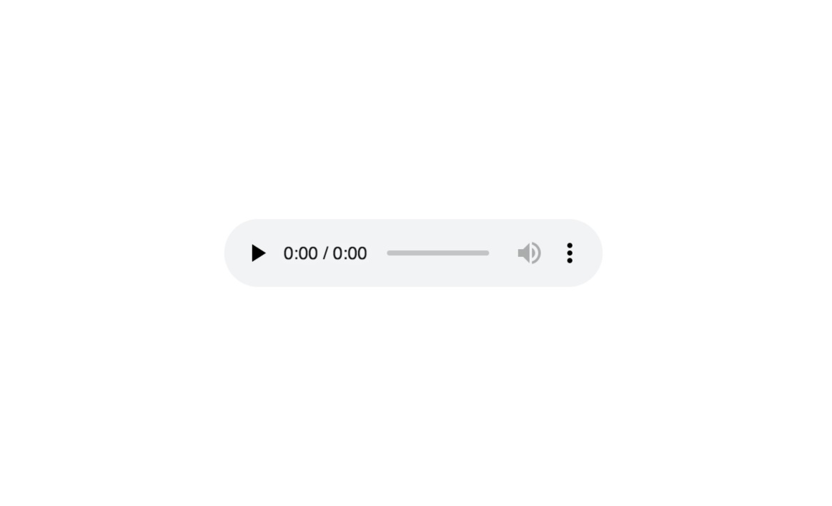

* Audio tag does not support width/height attribute (as it only displays audio content and has no visual display component).
* Audio tag does not support poster attribute neither as it does not has a visual display component.
* iframe tag
  + iframe tag enables us to embed other Web documents into current document. Common third-party content providers adopt this technique generally, such as comment system of Disqus and videos of online video providers.
  + Here is an example of iframe:

<iframe src="https://baidu.com"

width="500" height="500" frameborder="0"

allowfullscreen sandbox>

<p><a href="https://baidu.com">

Fallback link for browsers that don't support iframes

</a></p>

</iframe>

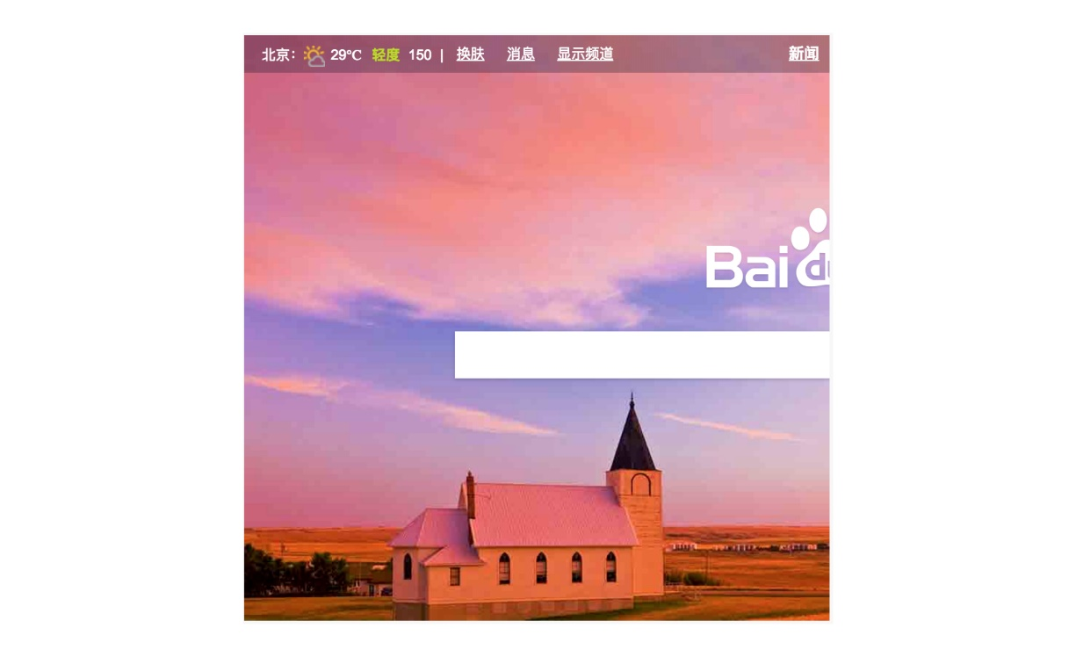

* Common attributes of iframe in the above example is introduced as below:
  + allowfullscreen. If it is set as true, iframe can display the current web page in full screen through the full screen interface.
  + frameborder. If it is set as 1, there will be a frame border of 1px between the current web page and the web page embedded by iframe; if it is set as 0, the frame border is deleted.
  + scr. It stands for address of the document to be linked by iframe.
  + width/height. It stands for width and height of iframe.
  + backup paragraph. Just as audio/video, when the browser does not support iframe tag, content of backup paragraph will be displayed.
  + sandbox. It is a security setting of modern browsers. In order to reduce attacks from hackers to the maximum extent, it is better to use sandbox attribute all the time. Contents not standboxed can do many unsecure things, such as execution of JavaScript and form submission.

**Recommended Resources**

* Multimedia and Embedding (<https://developer.mozilla.org/en-US/docs/Learn/HTML/Multimedia_and_embedding>)
* HTML Audio/Video DOM Reference (<https://www.w3schools.com/tags/ref_av_dom.asp>)
* HTML iframe Tag（<https://www.w3schools.com/html/html_iframe.asp>)